LECTURE 7
SCHEDULING ALGORITHMS

1. Introduction
1.1 CPU Scheduling
CPU Scheduling is the process used by the operating system to decide which process in the ready queue should get the CPU next.
In a multiprogramming system, multiple processes exist in memory at the same time, but only one process can use the CPU at a time.
Therefore, the operating system must schedule processes efficiently.
Key Idea
When the CPU becomes free, the CPU scheduler selects one process from the ready queue and allocates the CPU to it.
Why CPU Scheduling is Needed
CPU scheduling is required because:
- Many processes compete for CPU
- Only one process can run at a time
- The OS must decide which process runs first
Example
Suppose we have three processes waiting for CPU:
Process | CPU Burst Time
P1 | 10 ms
P2 | 4 ms
P3 | 6 ms
The CPU scheduler decides the execution order, for example:
P1 → P2 → P3
or
P2 → P3 → P1
Different scheduling algorithms produce different orders.
1.2 Objectives of CPU Scheduling
The main goal of CPU scheduling is to use the CPU efficiently and improve system performance.
The operating system tries to achieve the following objectives.
1. Maximize CPU Utilization
The CPU should stay busy as much as possible.
- Ideal case: CPU utilization close to 100%
- Avoid situations where the CPU is idle while processes are waiting
Example:
If CPU works 9 seconds out of 10 seconds, utilization = 90%.
2. Increase Throughput
Throughput = number of processes completed per unit time.
Example:
Time | Completed Processes
1 second | 5 processes
Throughput = 5 processes/second
Higher throughput means better system performance.
3. Reduce Turnaround Time
Turnaround Time = total time taken for a process to finish.
Formula:
Turnaround Time = Completion Time − Arrival Time
Example:
Process | Arrival | Completion
P1 | 0 | 20
Turnaround Time = 20 − 0 = 20 ms
Goal: Minimize turnaround time.
4. Reduce Waiting Time
Waiting Time is the total time a process waits in the ready queue before getting the CPU.
Formula:
Waiting Time = Turnaround Time − CPU Burst Time
Example:
Process | Burst | Turnaround
P1 | 5 | 15
Waiting Time = 15 − 5 = 10 ms
Goal: Minimize waiting time.
5. Improve Response Time
Response Time is the time from when a request is submitted until the first response is produced.
This is important in interactive systems.
Example:
User clicks a button → system responds in 0.5 seconds.
Goal: Fast response for users.

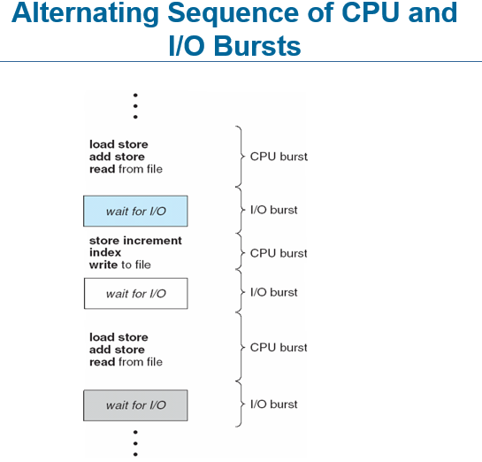

2. Schedulers
A scheduler is a part of the operating system that decides which processes should run and when.
Since many processes want to use the CPU, the OS uses different schedulers to manage them efficiently.
There are three types of schedulers.
2.1 Long-Term Scheduler (Job Scheduler)
Definition
The Long-Term Scheduler decides which new processes should be admitted into the system and placed in the ready queue.
Key Points
- Controls how many processes enter the system.
- Helps maintain the degree of multiprogramming (number of processes in memory).
- Runs infrequently (seconds or minutes).
Why it is important
It ensures a balanced mix of processes:
- CPU-bound processes
- I/O-bound processes
If too many CPU-bound processes enter the system, the CPU becomes overloaded.
Example
Suppose 10 programs request execution, but memory can handle only 5 processes.
The long-term scheduler selects 5 processes to load into memory.
2.2 Medium-Term Scheduler
Definition
The Medium-Term Scheduler temporarily removes processes from memory (suspends them) and later brings them back.
This process is called swapping.
Key Points
- Controls suspending and resuming processes
- Helps manage memory usage
- Improves system performance
Example
If memory becomes full:
- OS suspends process P3
- Saves it to disk
- Later resumes it when memory becomes available
2.3 Short-Term Scheduler (CPU Scheduler)
Definition
The Short-Term Scheduler selects which process in the ready queue gets the CPU next.
Key Points
- Runs very frequently (every few milliseconds)
- Must be very fast
- Directly controls CPU allocation
Example
Ready queue:
Process
P1
P2
P3
The short-term scheduler selects one process:
P2 → gets the CPU
Frequency of Schedulers
Scheduler | Runs How Often
Long-Term | Rarely (seconds/minutes)
Medium-Term | Occasionally
Short-Term | Very frequently (milliseconds)

3. Basic Concepts
3.1 Basic Concept of CPU Scheduling
In a computer system, a process does not use the CPU all the time.
Instead, it alternates between CPU work and I/O operations.
This pattern is called the CPU–I/O Burst Cycle.

3.2 CPU–I/O Burst Cycle
A process execution consists of repeated cycles of CPU execution and I/O waiting.
Two types of bursts:
- CPU Burst
  - Time during which a process uses the CPU for computation.
- I/O Burst
  - Time during which the process waits for input/output operations
(disk read, keyboard input, printing, etc.)
Process Execution Pattern
CPU → I/O → CPU → I/O → CPU → finish
Example:
CPU (5 ms) → Disk Read → CPU (3 ms) → Keyboard Input → CPU (4 ms)
So the CPU switches between different processes while others wait for I/O.
3.3 Alternating Sequence of CPU and I/O Bursts
During its lifetime, a process repeatedly performs:
- CPU work
- I/O operation
- CPU work
- I/O operation
Example sequence:
Step | Operation
1 | CPU Burst
2 | I/O Burst
3 | CPU Burst
4 | I/O Burst
5 | CPU Burst (finish)
This alternating pattern allows the OS to run another process when one process is waiting for I/O.
3.4 CPU Burst Distribution
In most systems:
- Many CPU bursts are short
- Few CPU bursts are long
This means:
- I/O-bound processes
  - Many short CPU bursts
  - Spend more time doing I/O
- CPU-bound processes
  - Few but very long CPU bursts
  - Spend most time computing
Example
Process Type | CPU Behavior
I/O-bound | Short CPU bursts
CPU-bound | Long CPU bursts
Operating systems try to balance both types of processes.

4. CPU Scheduling Components
CPU scheduling involves two important components:
- CPU Scheduler
- Dispatcher
4.1 CPU Scheduler
The CPU Scheduler selects a process from the ready queue and gives it the CPU.
When does CPU scheduling happen?
A scheduling decision occurs when a process:
- Running → Waiting
(e.g., requests I/O)
- Running → Ready
(preemption by OS)
- Waiting → Ready
(I/O completed)
- Process Terminates
Example
Ready Queue:
Process
P1
P2
P3
The CPU scheduler chooses one process, for example:
P2 → gets CPU
4.2 Dispatcher
The Dispatcher is the module that actually gives control of the CPU to the selected process.
Dispatcher Tasks
The dispatcher performs three main tasks:
- Context Switching
  - Saves current process state
  - Loads next process state
- Switch to User Mode
  - OS mode → user program mode
- Start the Selected Program
  - Jump to the correct instruction of the program
4.3 Dispatch Latency
Dispatch Latency is the time taken by the dispatcher to stop one process and start another.
Example:
Process P1 stops → OS loads P2 → CPU starts P2
The time taken during this switch = dispatch latency.
Important Idea
Lower dispatch latency = better system performance

5. Scheduling Criteria
When the operating system chooses a CPU scheduling algorithm, it evaluates it using certain performance measures called scheduling criteria.
These criteria help determine how efficient a scheduling algorithm is.
5.1 CPU Utilization
CPU Utilization measures how busy the CPU is.
Goal:
The CPU should be busy as much as possible.
Example:
Total Time | CPU Busy
10 seconds | 9 seconds
CPU Utilization = 90%
Higher CPU utilization means better system efficiency.
5.2 Throughput
Throughput is the number of processes completed per unit time.
Example:
Time | Processes Completed
1 second | 5 processes
Throughput = 5 processes/sec
Goal: Increase throughput.
More completed processes → better performance.
5.3 Turnaround Time
Turnaround Time is the total time taken for a process to finish execution.
Formula:
Turnaround Time = Completion Time − Arrival Time
Example:
Process | Arrival | Completion
P1 | 0 | 20
Turnaround Time = 20 − 0 = 20
Goal: Minimize turnaround time.
5.4 Waiting Time
Waiting Time is the total time a process spends waiting in the ready queue.
Formula:
Waiting Time = Turnaround Time − Burst Time
Example:
Burst | Turnaround
5 | 15
Waiting Time = 15 − 5 = 10
Goal: Minimize waiting time.
5.5 Response Time
Response Time is the time between submitting a request and getting the first response.
Important for interactive systems.
Example:
User clicks a button → system responds in 0.5 seconds.
Goal: Minimize response time.
Scheduling Algorithm Optimization Criteria
A good CPU scheduling algorithm should:
Maximize
- CPU Utilization
- Throughput
Minimize
- Turnaround Time
- Waiting Time
- Response Time

6. Scheduling Algorithms
A scheduling algorithm decides the order in which processes use the CPU.
Different algorithms are used depending on system requirements.
The first algorithm studied is FCFS.

6.1 First Come First Serve (FCFS)
Concept
In FCFS scheduling, the process that arrives first gets the CPU first.
It follows the FIFO principle (First In, First Out).
Think of it like a queue at a ticket counter.
First person in line → served first.
FCFS Example (Clear Flow)
Suppose three processes arrive at the same time.
Process | Burst Time
P1 | 24
P2 | 3
P3 | 3
Arrival order:
P1 → P2 → P3
Step 1: Draw Gantt Chart
Execution follows arrival order.
| P1 | P2 | P3 |
0 24 27 30
Step 2: Turnaround Time
Formula:
Turnaround = Completion − Arrival
Process | Completion | Arrival | Turnaround
P1 | 24 | 0 | 24
P2 | 27 | 0 | 27
P3 | 30 | 0 | 30
Average Turnaround Time
(24 + 27 + 30) / 3
= 27
Step 3: Waiting Time
Formula:
Waiting = Turnaround − Burst
Process | Burst | Turnaround | Waiting
P1 | 24 | 24 | 0
P2 | 3 | 27 | 24
P3 | 3 | 30 | 27
Average Waiting Time
(0 + 24 + 27) / 3
= 17
Convoy Effect
The Convoy Effect occurs when a long CPU process executes first, forcing short processes to wait.
This creates a situation where many short jobs are stuck behind a long job.
Example
Process | Burst Time
P1 | 20
P2 | 2
P3 | 3
Gantt Chart:
| P1 | P2 | P3 |
0 20 22 25
Problem:
- P2 and P3 must wait a long time
- CPU utilization decreases
- System performance becomes poor
Why Convoy Effect is Bad
Because:
- Short processes wait too long
- I/O devices remain idle
- Overall system efficiency decreases
How to Solve Convoy Effect
Better algorithms can reduce this problem:
- Shortest Job First (SJF)
- Round Robin
- Priority Scheduling
These algorithms allow shorter jobs to execute earlier.

6.2 Shortest Job First (SJF)
Concept
Shortest Job First (SJF) scheduling selects the process with the smallest CPU burst time to execute next.
In simple words:
The process that requires the least CPU time runs first.
Key Points
- Processes are scheduled based on shortest burst time.
- It produces the minimum average waiting time.
- Can be:
  - Non-Preemptive SJF
  - Preemptive SJF (Shortest Remaining Time First)
Problem with SJF
The main difficulty is:
We usually cannot know the exact CPU burst time in advance.
The OS must predict it using past behavior.
Example of SJF (Non-Preemptive)
Given Processes
Process | Burst Time
P1 | 6
P2 | 8
P3 | 7
P4 | 3
Assume all processes arrive at time 0.
Step 1: Arrange by Burst Time
Smallest burst time executes first.
Order becomes:
P4 → P1 → P3 → P2
Step 2: Draw Gantt Chart
| P4 | P1 | P3 | P2 |
0 3 9 16 24
Step 3: Turnaround Time
Formula:
Turnaround Time = Completion Time − Arrival Time
Process | Completion | Turnaround
P4 | 3 | 3
P1 | 9 | 9
P3 | 16 | 16
P2 | 24 | 24
Average Turnaround Time
(3 + 9 + 16 + 24) / 4
= 13
Step 4: Waiting Time
Formula:
Waiting Time = Turnaround − Burst
Process | Burst | Turnaround | Waiting
P4 | 3 | 3 | 0
P1 | 6 | 9 | 3
P3 | 7 | 16 | 9
P2 | 8 | 24 | 16
Average Waiting Time
(0 + 3 + 9 + 16) / 4
= 7
Shortest Remaining Time First (SRTF)
This is the preemptive version of SJF.
Concept
If a new process arrives with a smaller burst time than the remaining time of the current process, the CPU switches to the new process.
This switching is called preemption.
Example of SRTF (Preemptive SJF)
Given Processes
Process | Arrival Time | Burst Time
P1 | 0 | 8
P2 | 1 | 4
P3 | 2 | 9
P4 | 3 | 5
Step-by-Step Execution
Time 0
Only P1 is available.
Run P1
0 → 1
Remaining time of P1 = 7
Time 1
Process P2 arrives (burst 4)
Compare:
P1 remaining = 7
P2 burst = 4
P2 is smaller → preempt P1
Run P2
1 → 5
P2 finishes.
Time 5
Available processes:
Process | Remaining
P1 | 7
P3 | 9
P4 | 5
Smallest = P4
Run P4
5 → 10
P4 finishes.
Time 10
Remaining:
Process | Remaining
P1 | 7
P3 | 9
Smallest = P1
Run P1
10 → 17
P1 finishes.
Time 17
Only P3 remains.
Run P3
17 → 26
Final Gantt Chart
| P1 | P2 | P4 | P1 | P3 |
0 1 5 10 17 26
Advantages of SJF
- Minimum average waiting time
- Efficient for batch systems
Disadvantages
- Difficult to predict CPU burst time
- Can cause starvation (long processes wait too long)

6.3 Priority Scheduling
Concept
In Priority Scheduling, every process is assigned a priority number.
The CPU is allocated to the process with the highest priority.
Usually:
- Smaller number = higher priority
Example:
Process | Priority
P1 | 1
P2 | 3
P3 | 5
Execution order:
P1 → P2 → P3
Types of Priority Scheduling
1. Non-Preemptive Priority Scheduling
Once a process starts executing, it cannot be interrupted until it finishes.
Even if a higher priority process arrives, the current process continues running.
2. Preemptive Priority Scheduling
If a new process arrives with higher priority, it immediately takes the CPU.
The current process is interrupted (preempted).
Example 1: Priority Scheduling (Non-Preemptive)
Given Processes
Process | Arrival Time | Burst Time | Priority
P1 | 0 | 10 | 3
P2 | 1 | 1 | 1
P3 | 2 | 2 | 4
P4 | 3 | 1 | 5
P5 | 4 | 5 | 2
Reminder:
Lower number = higher priority
Step 1: Execution Order
At time 0, only P1 is available → run P1
Since it is non-preemptive, P1 finishes completely.
Then choose the highest priority from remaining processes.
Remaining priorities:
Process | Priority
P2 | 1
P5 | 2
P3 | 4
P4 | 5
Execution order becomes:
P1 → P2 → P5 → P3 → P4
Step 2: Gantt Chart
| P1 | P2 | P5 | P3 | P4 |
0 10 11 16 18 19
Step 3: Turnaround Time
Formula:
Turnaround = Completion − Arrival
Process | Completion | Arrival | Turnaround
P1 | 10 | 0 | 10
P2 | 11 | 1 | 10
P5 | 16 | 4 | 12
P3 | 18 | 2 | 16
P4 | 19 | 3 | 16
Step 4: Waiting Time
Formula:
Waiting = Turnaround − Burst
Process | Burst | Turnaround | Waiting
P1 | 10 | 10 | 0
P2 | 1 | 10 | 9
P5 | 5 | 12 | 7
P3 | 2 | 16 | 14
P4 | 1 | 16 | 15
Problem: Starvation
Definition
Starvation occurs when a low-priority process waits indefinitely because higher-priority processes keep executing.
Example:
Process | Priority
P1 | 1
P2 | 2
P3 | 10
If new high-priority processes keep arriving, P3 may never run.
This is called indefinite blocking.
Solution: Aging
Aging is a technique used to prevent starvation.
The idea is:
Increase the priority of a process the longer it waits.
Eventually, the process becomes high priority and gets CPU time.
Aging Example
Initial priority:
Process | Priority
P3 | 5
After waiting:
Priority becomes:
5 → 4 → 3 → 2 → 1
Now P3 will eventually become highest priority and execute.
Example 2: Priority Scheduling (Preemptive)
Given Processes
Process | Arrival | Burst | Priority
P1 | 0 | 7 | 3
P2 | 2 | 4 | 1
P3 | 4 | 2 | 2
Lower number = higher priority.
Step-by-Step Execution
Time 0
Only P1 available.
Run P1
0 → 2
Remaining time of P1 = 5
Time 2
P2 arrives (priority 1)
P2 has higher priority than P1.
So preempt P1.
Run P2
2 → 6
P2 finishes.
Time 6
Processes available:
Process | Remaining | Priority
P1 | 5 | 3
P3 | 2 | 2
Highest priority = P3
Run P3
6 → 8
Time 8
Only P1 remains.
Run P1
8 → 13
Final Gantt Chart
| P1 | P2 | P3 | P1 |
0 2 6 8 13
Advantages of Priority Scheduling
- Important processes execute first
- Useful in real-time systems
Disadvantages
- Starvation problem
- Lower priority processes may wait too long

6.4 Round Robin (RR)
Concept
Round Robin (RR) scheduling is designed for time-sharing systems.
In this algorithm:
- Each process gets a fixed amount of CPU time called Time Quantum (q).
- After the time quantum expires, the process is preempted and moved to the end of the ready queue.
Then the next process gets the CPU.
Key Idea
Instead of one process using the CPU for a long time, all processes share the CPU fairly.
Execution style:
P1 → P2 → P3 → P1 → P2 → P3 ...
Each process gets a small CPU slice.
Time Quantum (q)
Time Quantum is the maximum CPU time given to a process in one turn.
Typical value:
- 10 ms – 100 ms
Important Cases
If Time Quantum is Very Large
Round Robin behaves like FCFS.
Example:
q = very large
P1 finishes before switching
So execution becomes:
P1 → P2 → P3
If Time Quantum is Very Small
Too many context switches occur.
This causes high overhead and reduces system performance.
Context Switch
A context switch occurs when the CPU switches from one process to another.
During context switch:
- Current process state is saved
- Next process state is loaded
Too many context switches → wastes CPU time.
Example 1: Round Robin (Time Quantum = 4)
Given Processes
Process | Burst Time
P1 | 24
P2 | 3
P3 | 3
Time Quantum:
q = 4
Step-by-Step Execution
Step 1
Run P1 for 4 units.
Remaining burst:
P1 = 24 − 4 = 20
0 → 4
Step 2
Run P2.
P2 burst = 3 < 4 → finishes.
4 → 7
Step 3
Run P3
P3 burst = 3 → finishes.
7 → 10
Step 4
Return to P1
Run for 4 again.
10 → 14
Remaining = 16
Continue same process until P1 finishes.
Final Gantt Chart
| P1 | P2 | P3 | P1 | P1 | P1 | P1 | P1 |
0 4 7 10 14 18 22 26 30
Performance Observation
Round Robin usually gives:
- Better response time
- Fair CPU sharing
But:
- Turnaround time may be higher than SJF
Turnaround Time vs Time Quantum
Turnaround time depends heavily on the time quantum.
If q is too large:
- behaves like FCFS
If q is too small:
- too many context switches
Rule used in practice:
About 80% of CPU bursts should be smaller than the time quantum.
Example 2: Round Robin (Time Quantum = 2)
Given Processes
Process | Arrival Time | Burst Time
A | 0 | 5
B | 2 | 3
C | 3 | 2
D | 4 | 3
Time Quantum:
q = 2
Step-by-Step Execution
Time 0
Run A
0 → 2
Remaining:
A = 3
Time 2
Process B arrives
Run B
2 → 4
Remaining:
B = 1
Time 4
Processes available:
A, B, C, D
Run A
4 → 6
Remaining:
A = 1
Time 6
Run C
C burst = 2 → finishes
6 → 8
Time 8
Run D
8 → 10
Remaining:
D = 1
Time 10
Run B
10 → 11
B finishes.
Time 11
Run A
11 → 12
A finishes.
Time 12
Run D
12 → 13
D finishes.
Final Gantt Chart
| A | B | A | C | D | B | A | D |
0 2 4 6 8 10 11 12 13
Advantages of Round Robin
- Fair scheduling
- Good response time
- Ideal for time-sharing systems
Disadvantages
- Too many context switches if quantum is small
- Higher average turnaround time compared to SJF

7. Advanced Scheduling Techniques
Sometimes basic scheduling algorithms (FCFS, SJF, RR, Priority) are not enough for complex systems.
Operating systems therefore use advanced scheduling techniques that combine multiple algorithms.
Main techniques:
- Multilevel Queue Scheduling
- Priority + Round Robin
- Multilevel Feedback Queue

7.1 Multilevel Queue Scheduling
Concept
In Multilevel Queue Scheduling, the ready queue is divided into multiple separate queues based on process type.
Each queue has its own scheduling algorithm.
Processes are permanently assigned to one queue.
Example Queue Structure
Example system:
Queue | Process Type | Scheduling
Foreground Queue | Interactive processes | Round Robin
Background Queue | Batch processes | FCFS
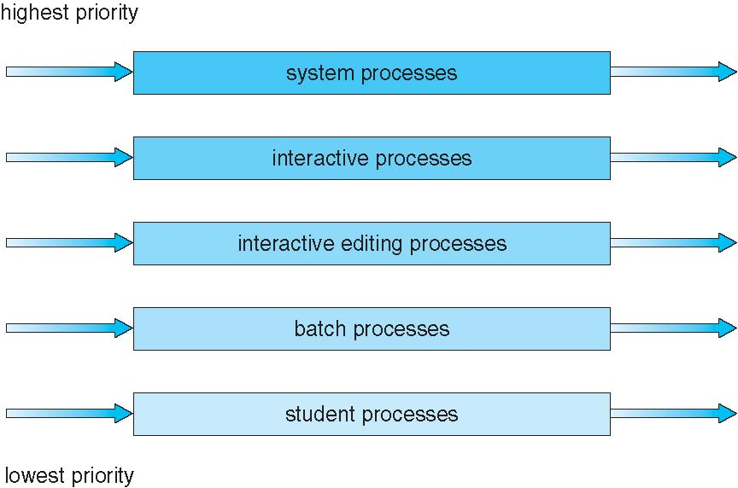
Scheduling Between Queues
There are two main methods.
1. Fixed Priority Scheduling
Higher priority queue is always served first.
Example:
Foreground queue → first
Background queue → second
Problem:
Background processes may suffer starvation.
2. Time Slice Between Queues
CPU time is divided among queues.
Example:
Queue | CPU Time
Foreground | 80%
Background | 20%
This prevents starvation.
Example of Multilevel Queue Scheduling
Processes
Process | Type | Burst Time
P1 | Interactive | 4
P2 | Batch | 10
P3 | Interactive | 3
P4 | Batch | 6
Queue assignment:
Foreground (RR) → P1, P3
Background (FCFS) → P2, P4
Step 1: Execute Foreground Queue (Round Robin)
Time quantum = 2
| P1 | P3 | P1 | P3 |
0 2 4 6 7
Foreground processes finish first.
Step 2: Execute Background Queue (FCFS)
| P2 | P4 |
7 17 23
Final Execution
| P1 | P3 | P1 | P3 | P2 | P4 |
0 2 4 6 7 17 23

7.2 Priority Scheduling with Round Robin
Concept
In this method:
- Processes are grouped by priority.
- Higher priority group runs first.
- Processes with the same priority are scheduled using Round Robin.
This combines:
- Priority Scheduling
- Round Robin
Example
Given Processes
Process | Burst Time | Priority
P1 | 4 | 3
P2 | 5 | 2
P3 | 8 | 2
P4 | 7 | 1
P5 | 3 | 3
Rule:
- Smaller number = higher priority
- Time quantum = 2
Step 1: Arrange by Priority
Priority 1 → P4
Priority 2 → P2, P3
Priority 3 → P1, P5
Step 2: Execute Priority 1
Only P4
| P4 |
0 7
Step 3: Priority 2 (Round Robin)
Processes: P2, P3
| P2 | P3 | P2 | P3 | P2 | P3 |
7 9 11 13 15 16 18
P2 finishes at 16
P3 finishes at 20
Step 4: Priority 3 (Round Robin)
Processes: P1, P5
| P1 | P5 | P1 | P5 |
20 22 24 26 27
Final Gantt Chart
| P4 | P2 | P3 | P2 | P3 | P2 | P3 | P1 | P5 | P1 | P5 |
0 7 9 11 13 15 16 18 20 22 24 26 27

7.3 Multilevel Feedback Queue (MLFQ)
Concept
In Multilevel Feedback Queue, processes can move between different queues based on their behavior.
This helps balance:
- Short interactive processes
- Long CPU-bound processes
Unlike Multilevel Queue:
Processes are not fixed to one queue.
Key Characteristics
MLFQ defines:
- Number of queues
- Scheduling algorithm for each queue
- Rules for moving processes between queues
Example of Multilevel Feedback Queue
Queue Structure
Queue | Algorithm | Time Quantum
Q0 | Round Robin | 8 ms
Q1 | Round Robin | 16 ms
Q2 | FCFS | No limit
Rules
- New processes enter Q0.
- If not finished in 8 ms, move to Q1.
- If still not finished in 16 ms, move to Q2.
Example
Processes
Process | Burst Time
P1 | 5
P2 | 20
P3 | 30
Step 1: Q0 (Time Quantum = 8)
P1 runs 5 → finishes
P2 runs 8 → remaining 12
P3 runs 8 → remaining 22
Gantt chart:
| P1 | P2 | P3 |
0 5 13 21
Move P2 and P3 to Q1
Step 2: Q1 (Time Quantum = 16)
P2 runs 12 → finishes
P3 runs 16 → remaining 6
| P2 | P3 |
21 33 49
Move P3 to Q2
Step 3: Q2 (FCFS)
P3 runs remaining 6
| P3 |
49 55
Final Execution
| P1 | P2 | P3 | P2 | P3 | P3 |
0 5 13 21 33 49 55
Advantages of Multilevel Feedback Queue
- Adapts to process behavior
- Good for interactive systems
- Reduces starvation
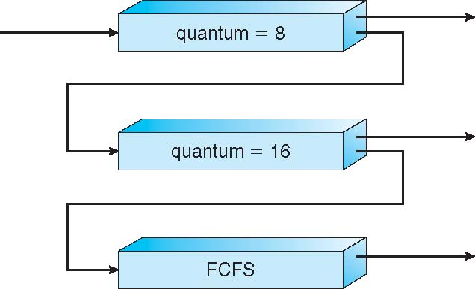

8. Thread Scheduling
Concept
In systems that support multithreading, the operating system schedules threads instead of entire processes.
A thread is the smallest unit of CPU execution.
Example:
A web browser process may contain multiple threads:
- Page loading thread
- Image rendering thread
- Download thread
The CPU scheduler decides which thread runs next.
Types of Thread Scheduling
Thread scheduling depends on where scheduling decisions are made.
There are two main types:
- Process-Contention Scope (PCS)
- System-Contention Scope (SCS)
8.1 Process-Contention Scope (PCS)
Concept
In PCS, threads compete with other threads within the same process for CPU time.
The thread library inside the process schedules them.
This means:
Threads compete inside the process, not across the entire system.
Example
Suppose we have a process P1 with 3 threads:
Thread | Task
T1 | File reading
T2 | Image processing
T3 | Data calculation
Inside process P1, the thread library decides the order:
T1 → T2 → T3
Other processes are not involved in this scheduling decision.
Key Points
- Scheduling happens inside the process
- Managed by thread library
- Used in user-level thread models
8.2 System-Contention Scope (SCS)
Concept
In SCS, threads compete with all threads in the system for CPU time.
The operating system kernel schedules them.
This means:
Threads from different processes compete for CPU.
Example
Suppose we have threads from different processes:
Process | Thread
P1 | T1
P1 | T2
P2 | T3
P3 | T4
All threads compete together:
T1 → T3 → T2 → T4
The kernel scheduler decides execution order.
Key Points
- Scheduling done by OS kernel
- Threads compete system-wide
- Used in kernel-level thread models
Difference Between PCS and SCS
Feature | PCS | SCS
Competition | Within process | Entire system
Managed by | Thread library | OS kernel
Scope | Process level | System level

Pthread Scheduling
Pthreads (POSIX Threads) is a standard API used for multithreading in C/C++ programs.
It allows programmers to:
- Create threads
- Control thread behavior
- Set scheduling policies
Pthread Scheduling Scope
When creating threads, you can specify the scheduling scope.
Two options:
Scope | Meaning
PTHREAD_SCOPE_PROCESS | Uses PCS scheduling
PTHREAD_SCOPE_SYSTEM | Uses SCS scheduling
However:
Most modern systems (Linux, MacOS) support only SYSTEM scope.
Pthread Scheduling Policies
Threads can use different scheduling policies:
Policy | Description
SCHED_FIFO | First-in-first-out real-time scheduling
SCHED_RR | Round Robin scheduling
SCHED_OTHER | Default system scheduling

Pthread Scheduling API Example
Example C code for creating threads with scheduling attributes:
#include <pthread.h>
#include <stdio.h>
#define NUM_THREADS 5
void *runner(void *param)
{
printf("I am a thread\n");
pthread_exit(0);
}
int main()
{
pthread_t tid[NUM_THREADS];
pthread_attr_t attr;
pthread_attr_init(&attr);
pthread_attr_setscope(&attr, PTHREAD_SCOPE_SYSTEM);
pthread_attr_setschedpolicy(&attr, SCHED_OTHER);
for(int i=0;i<NUM_THREADS;i++)
pthread_create(&tid[i], &attr, runner, NULL);
for(int i=0;i<NUM_THREADS;i++)
pthread_join(tid[i], NULL);
}
What This Code Does
- Initializes thread attributes
- Sets scheduling scope to system level
- Sets scheduling policy
- Creates multiple threads
- Waits for all threads to finish
Each thread prints: I am a thread

9. Multiprocessor Scheduling
Concept
Multiprocessor Scheduling deals with scheduling processes when a system has more than one CPU.
In such systems:
- Multiple processors execute tasks simultaneously.
- The OS must decide which processor runs which process.
Example systems:
- Multi-core CPUs
- Servers with multiple processors
- Parallel computing systems
Example of Multiprocessor System
Suppose a system has 4 CPUs:
CPU1 CPU2 CPU3 CPU4
Processes ready to run:
P1, P2, P3, P4, P5
Possible scheduling:
CPU1 → P1
CPU2 → P2
CPU3 → P3
CPU4 → P4
When one finishes, P5 can run next.
This allows parallel execution, increasing performance.
Types of Multiprocessor Scheduling
Two main approaches:
- Asymmetric Multiprocessing (AMP)
- Symmetric Multiprocessing (SMP)
9.1 Asymmetric Multiprocessing (AMP)
Concept
In Asymmetric Multiprocessing, one processor controls the system.
This processor is called the master processor.
Other processors are called slave processors.
The master processor:
- Handles scheduling
- Manages I/O
- Assigns work to other CPUs
Structure
Master CPU → Scheduling decisions
Slave CPU1 → Executes tasks
Slave CPU2 → Executes tasks
Slave CPU3 → Executes tasks
Example
Suppose we have:
CPU1 (Master)
CPU2
CPU3
Processes:
P1, P2, P3, P4
Scheduling:
CPU1 (Master) → assigns tasks
CPU2 → P1
CPU3 → P2
CPU1 → P3
When a CPU becomes free:
Master assigns P4
Advantages
- Simple to implement
- No complex synchronization between CPUs
Disadvantages
- Master processor becomes bottleneck
- System performance depends heavily on one CPU
9.2 Symmetric Multiprocessing (SMP)
Concept
In Symmetric Multiprocessing, all processors are equal.
Each CPU:
- Runs its own scheduler
- Executes processes independently
There is no master processor.
Structure
CPU1 → Scheduler
CPU2 → Scheduler
CPU3 → Scheduler
CPU4 → Scheduler
Each CPU chooses a process from the ready queue.
Example
Suppose we have 3 CPUs:
CPU1, CPU2, CPU3
Processes:
P1, P2, P3, P4, P5
Execution:
CPU1 → P1
CPU2 → P2
CPU3 → P3
After finishing:
CPU1 → P4
CPU2 → P5
All CPUs work simultaneously.
Advantages
- Better load balancing
- Higher performance
- No single bottleneck
Disadvantages
- Requires complex synchronization
- Shared data structures must be protected
9.3 Processor Affinity
Concept
Processor Affinity means a process prefers to run on the same CPU where it ran before.
Reason:
When a process runs on a CPU:
- Its data is stored in that CPU's cache.
If moved to another CPU:
- Cache must be reloaded
- Performance decreases
Therefore OS tries to keep process on same CPU.
Example
System with 2 CPUs:
CPU1 CPU2
Process P1 previously ran on CPU1.
If scheduled again:
CPU1 → P1 (preferred)
Instead of:
CPU2 → P1
This keeps cache data valid.
Types of Processor Affinity
Two types:
- Soft Affinity
- Hard Affinity
9.3.1 Soft Affinity
Concept
In Soft Affinity, the OS tries to keep a process on the same CPU, but it is not guaranteed.
If system load changes:
The OS may move the process to another CPU.
Example
System:
CPU1, CPU2
Process P1 previously ran on CPU1.
Scheduler preference:
CPU1 → P1
But if CPU1 is busy:
CPU2 → P1
So affinity is preferred but flexible.
9.3.2 Hard Affinity
Concept
In Hard Affinity, a process is restricted to specific CPUs.
The OS cannot move it to other CPUs.
This is also called CPU pinning.
Example
Suppose process P2 is assigned only to CPU2.
Allowed execution:
CPU2 → P2
Not allowed:
CPU1 → P2 ❌
Even if CPU1 is idle.
Advantages of Processor Affinity
- Better cache utilization
- Improved performance
- Reduced memory access time

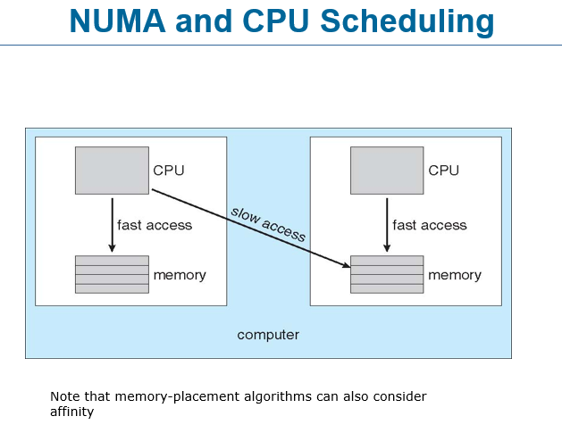
NUMA and CPU Scheduling
Non-Uniform Memory Access (NUMA) is a memory architecture used in multiprocessor systems where each CPU has its own local memory. In this design, the access time to memory is not the same for all CPUs, which is why it is called non-uniform. The diagram shows two CPUs, each connected to its own local memory. When a CPU accesses its own local memory, the access is fast because the memory is directly attached to that processor. However, when a CPU needs to access the memory connected to another CPU, the request must travel through the interconnection between processors, making the access slower.
In the diagram, the left CPU has fast access to the memory located directly below it. Similarly, the right CPU has fast access to its own local memory. The diagonal arrow labeled slow access represents the situation where a CPU tries to access memory belonging to the other processor. Because the data must travel across the system interconnect, this operation takes more time compared to accessing local memory. Therefore, the performance of the system can vary depending on where the data is stored and which CPU is executing the process.
CPU scheduling in NUMA systems must consider this difference in memory access speed. If a process frequently uses data stored in the memory attached to a particular CPU, it is more efficient for the scheduler to run that process on the same CPU. Running the process on another CPU would require repeated remote memory accesses, which are slower and reduce performance. Therefore, operating systems try to maintain CPU affinity, meaning they attempt to keep a process running on the processor where its memory is located.
Memory-placement algorithms also consider this concept of affinity. When a process starts, the system tries to place its memory in the local memory of the CPU that will execute it. This ensures faster memory access and better overall performance. By keeping both the process and its memory close to each other, the system minimizes slow remote memory accesses and improves efficiency in multiprocessor environments.

